**ISMG 4750 Business Intelligence and Financial Modelling- Assignment**

**Prathamesh_Dhapodkar_109171717**

The Chapter 1 of analysis displays the regional comparison of the colleges in the states of California, Colorado and Texas. And Chapter 2 displays the specific range of colleges and their comparison in terms of different descriptive characteristics.

In Chapter 1, I made 4 visualization for analysis, 1st quadrant displays the regions and admission rate for the region focused for the analysis and also provides a filter for the other visualizations. In 2nd quadrant the visualization displays the best and worse college in terms of admission rate overall as well as specific to the region. The best college accepted overall is The University of Texas EL Paso with highest acceptance rate among the three regions. The third visual shows the acceptance rate in terms of Sat scores. Harvey Mudd College is the college, which would accept you easily if you have a higher SAT score. Similarly, Visual 4 display the acceptance rate of college in terms of ACT scores. Though there are many colleges which do not consider writing section of the ACT exam, but this data is culminated result of colleges accepting all three scores. Rice university would easily accept you if you have high score in ACT.

Chapter 2 of the dossier is the comparison of the colleges to the admission range of University of Colorado - Colorado Springs, University of Colorado Denver and University of Colorado Boulder. In Visualization 1 we can see the admission rates of universities across Colorado, using the filter for states and it also shows the college which requires max SAT and ACT scores respectively. So, for the state of Colorado, Colorado college requires the highest SAT and ACT score. Similarly adding filter to set the range for admission rate would give us the visual 2, where we can see the colleges across the country which have the acceptance rate within the set range, where we also notice that university of Colorado – Colorado springs has highest admission rate. Visual 3 shows the university which has least amount of in state fees in the set range the university of Texas of the Permian basin is the college with least tuition fees. Visual 4 shows the best university with max no. of degree seeking students. That may also signify that the university provides the high-level STEM courses.

The most significant attributes in the dossier are INSTNM, STABBR helped for filtering as well as in many visuals. There are many matrices for the purpose like, SAT AVG, ACT AVG(modified), TUTIONFEE IN etc.

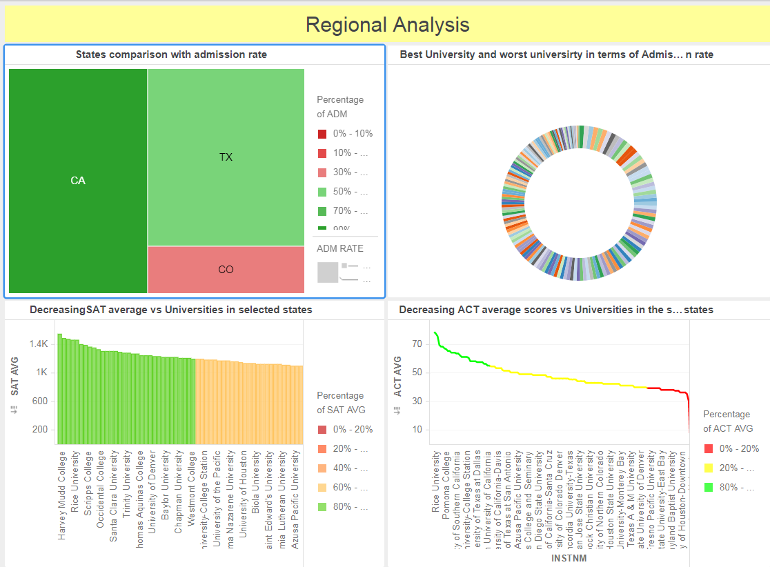

Chapter 1

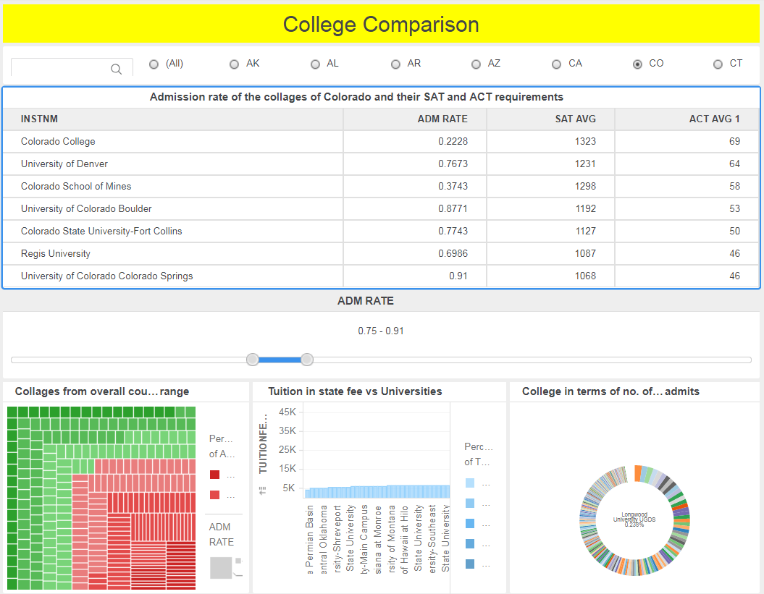

Chapter 2